Course information for the Parish Newsletter

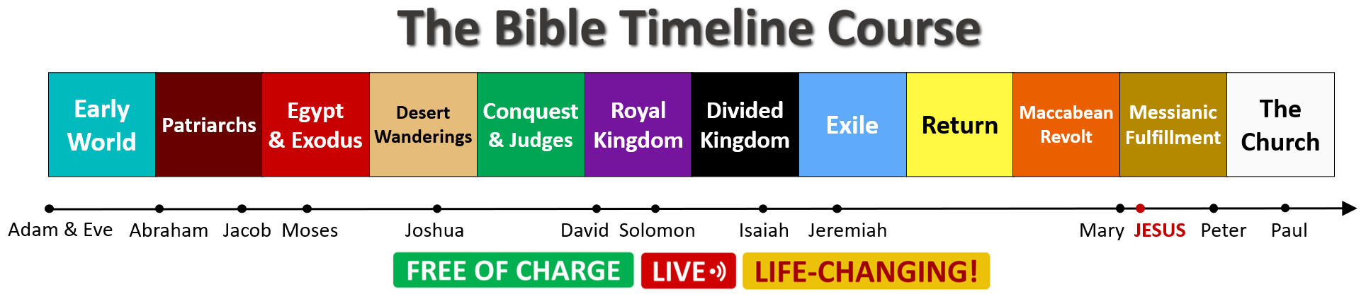

THE BIBLE TIMELINE COURSE
Understand the Bible from start to finish, the Old and New Testament, with this FREE OF CHARGE, worldwide-famous course delivered online LIVE by Mauro Iannicelli.
Starts Wed 29th September 2021. Eight Wednesday sessions (7pm-8:40pm).
Info & Registration: www.comeandsee.org

Please Note: For best results, try to include the image of the 12 colour-coded Biblical periods in the Newsletter, as shown below.

